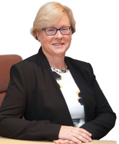

Barbara Heslin
Director of Services Longford County Council
Barbara is a graduate of NUI Galway and Chartered Accountant by profession with extensive experience in both the public and private sectors.
Barbara joined Longford County Council in 2015 as Director of Services having previously worked with the Irish Prison Service and KPMG. In her current role, her responsibilities include Economic and Community Development, Library Service, Arts Service, Culture, Corporate Services and Human Resources.

